PBL- Israel Palestine History Notes
you DO NOT need to use complete sentences, be as concise as possible
What 3 pieces of land are involved in the conflict?  At the heart of the conflict, what is the dispute over? | Who is involved?
Israel Today: | Palestine Today:

Country Recognition:
What is Palestine?
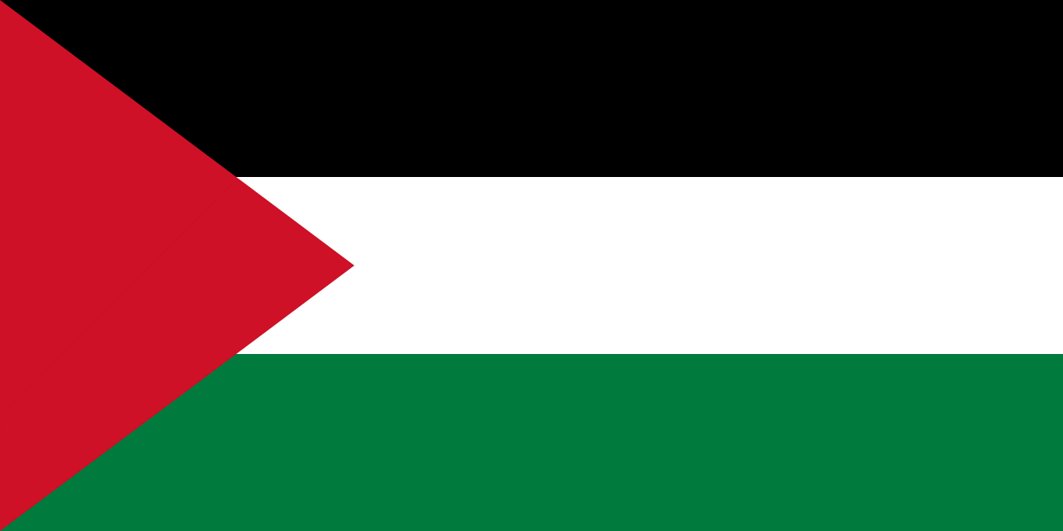
http://www.history.com/topics/palestine

Oslo Accords

First Intifada

Second Intifada

Hamas

1500’s-WW1
Pre-1500’s
Palestinian History
1970-1993
1947-1967

Partition-

PLO-

6 Day War-

Jewish History

Post WW2
WW1 & WW2
Ancient Times-1800’s

Partition Plan of 1947-

1948 Arab-Israeli War-

6 day War-

Balfour Declaration-

Who owned the land?

Was it called Israel?

Holocaust- during WW2
- Antisemitism

Early History

Zionism 1800s-

1517-1917-

